LogicDS is a recently NSF DRK-12 funded project. Data science is an interdisciplinary subject driven by real-world applications and builds on foundations in computing, math, and statistics. It provides excellent opportunities, not only for high school students to prepare their future careers, but also to develop college-ready STEM competencies. However, these opportunities are still inaccessible to the vast majority of students, particularly those from rural communities, because of the complexity of the overlapping disciplines from mathematics, statistics to computer science and the lack of flexible and reliable learning and teaching resources. We propose an innovative approach to integrating the foundations of data science into one course, named as LogicDS using mathematical logic. Mathematical logic provides a language for us to develop precise definitions of statistics concepts to explicate the logic and reasoning underlying these concepts, and thus promote deeper sense making and reasoning. Furthermore, the learning activities will be contextualized in developing computer models to explore real-world problems using datasets of the United Nation Sustainable Development Goals (SDGs). The LogicDS course will be amplified to reach students of rural communities by our partnership with Florida Virtual School (FLVS), a leader in online K-12 education. FLVS’s effective online teaching and learning practices, augmented by personalized learning, provide equal opportunities for data science learning for anyone at anytime from anywhere.

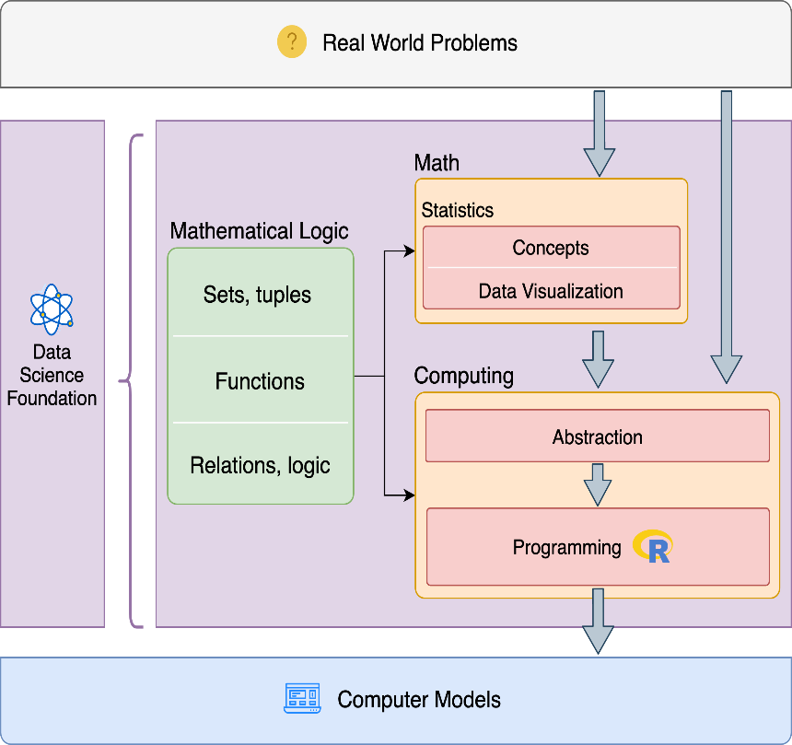

**Conceptual Framework of the Integration by Mathematical Logic**

Relevant publications

Check out later